LINUX BASICS — DEVOPS ASSIGNMENT

Student Details
Name: Rupali Kushwaha
Subject: DevOps
Assignment: Linux Basics
Date: 19 September 2026
GitHub Repository: https://github.com/KUSHRUP/Linux-Basics-DevOps.git

Objective
The objective of this assignment is to practise essential Linux command-line operations, including file and directory management, viewing file contents, searching for patterns, compressing and extracting files, downloading files, changing file permissions, and working with environment variables.
All tasks were performed using the Linux terminal on Ubuntu.

Task 1 — Creating and Renaming Files/Directories

1. Create a directory named test_dir

Command
mkdir test_dir

Explanation
The mkdir command is used to create a new directory. The above command creates a directory named test_dir in the current working directory.

2. Create an empty file named example.txt

Command
touch test_dir/example.txt

Explanation
The touch command is used to create an empty file. Here, an empty file named example.txt was created inside the test_dir directory.

3. Rename example.txt to renamed_example.txt

Command
mv test_dir/example.txt test_dir/renamed_example.txt

Explanation
The mv command is used to move or rename files and directories. Here, example.txt was renamed to renamed_example.txt.

Verification
ls test_dir

Output
renamed_example.txt

Screenshot
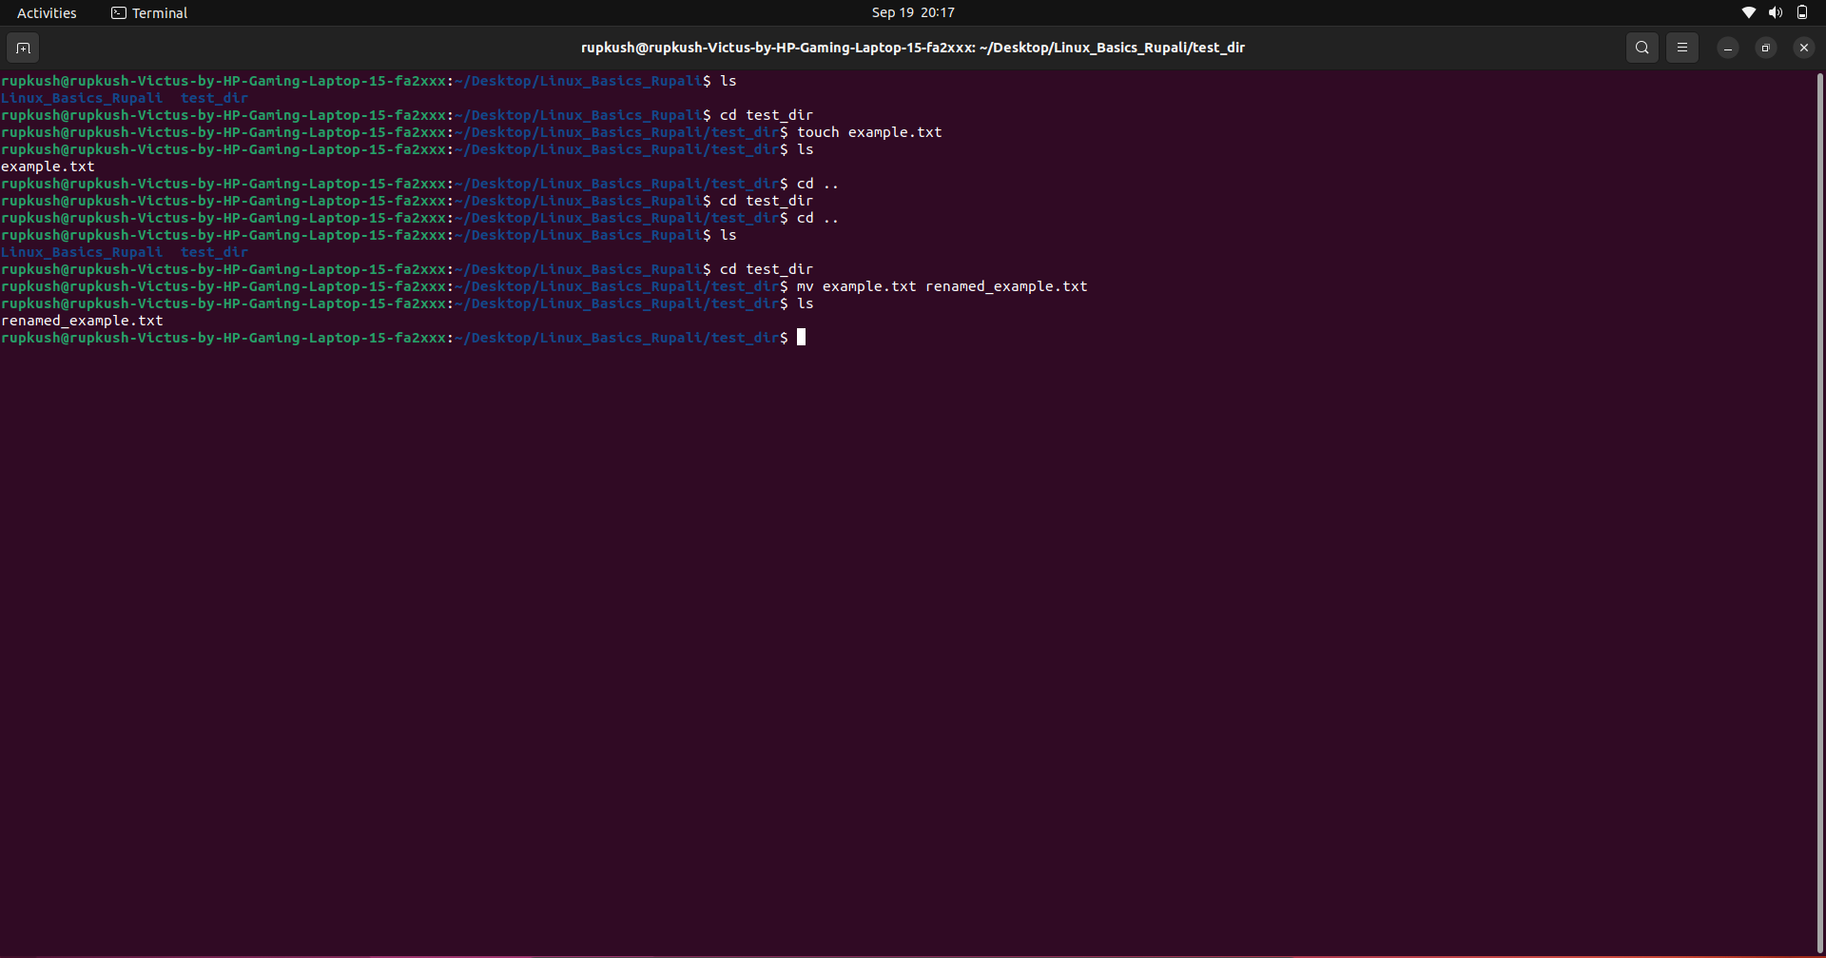

Task 2 — Viewing File Contents

4. Display the contents of /etc/passwd using cat

Command
cat /etc/passwd

Explanation
The cat command is used to display the contents of a file in the terminal. The /etc/passwd file contains information about user accounts configured on the Linux system.

Screenshot
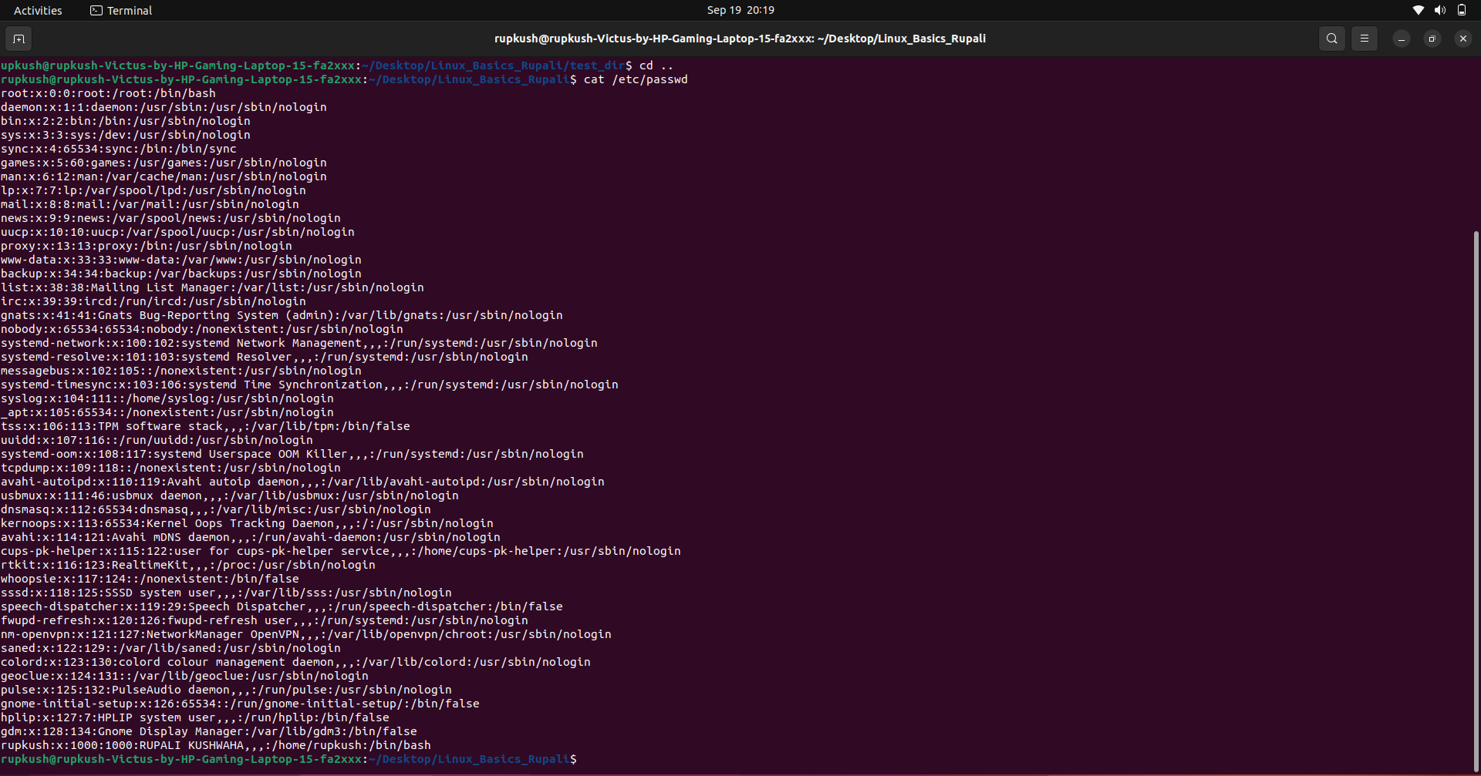

5. Display the first 5 lines using head

Command
head -n 5 /etc/passwd

Explanation
The head command displays the beginning of a file. The -n 5 option specifies that only the first five lines should be displayed.

Screenshot
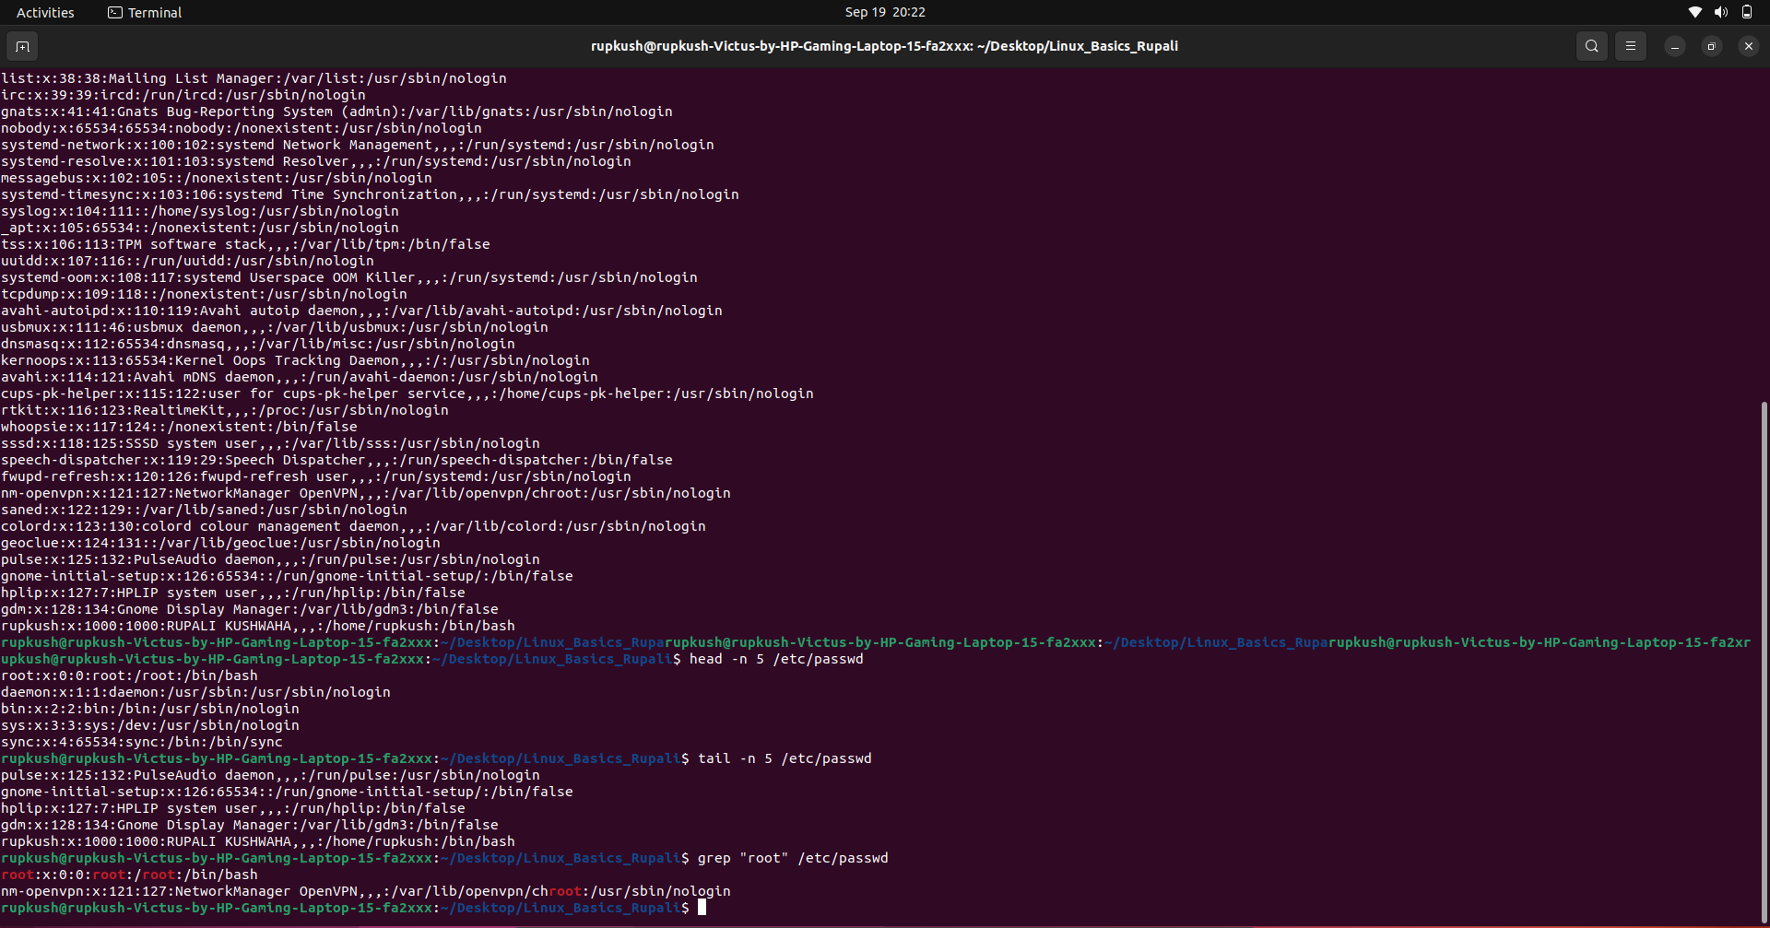

6. Display the last 5 lines using tail

Command
tail -n 5 /etc/passwd

Explanation
The tail command displays the end of a file. The -n 5 option specifies that only the last five lines should be displayed.

Screenshot

Task 3 — Searching for Patterns

7. Find all lines containing the word root

Command
grep "root" /etc/passwd

Explanation
The grep command is used to search for a particular text pattern inside a file. In this task, it searches /etc/passwd for lines containing the word root.

Example Output
root:x:0:0:root:/root:/bin/bash
nm-openvpn:x:121:127:NetworkManager OpenVPN,,,:/var/lib/openvpn/chroot:/usr/sbin/nologin

Screenshot

Task 4 — Zipping and Unzipping

8. Compress the test_dir directory

Command
zip -r test_dir.zip test_dir

Explanation
The zip command is used to compress files and directories into a ZIP archive. The -r option allows the command to recursively include the contents of the directory.
The directory test_dir was compressed into:
test_dir.zip

Verification
ls -lh
The ZIP file was successfully created.

Screenshot
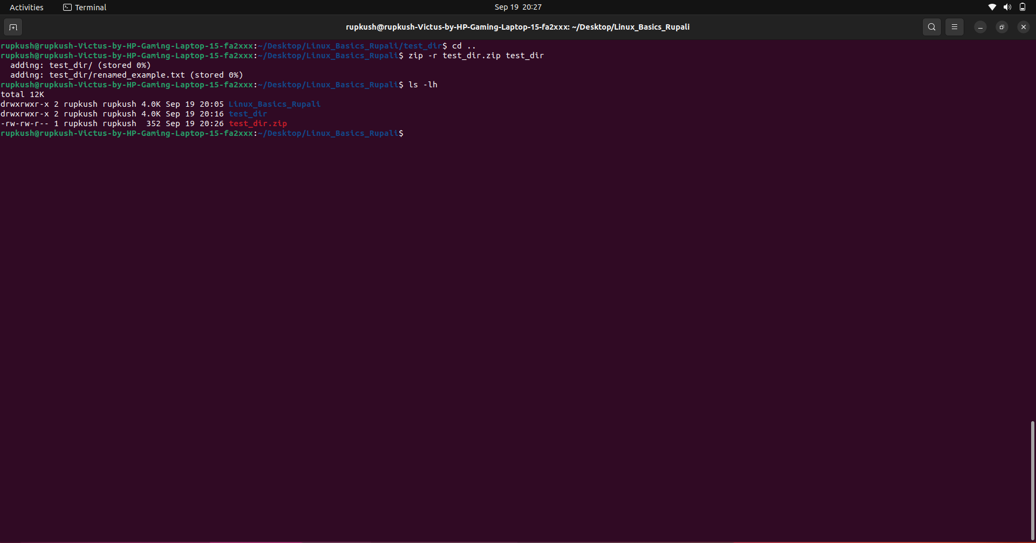

9. Unzip test_dir.zip into unzipped_dir

Commands
mkdir unzipped_dir
unzip test_dir.zip -d unzipped_dir

Explanation
The mkdir command creates the destination directory unzipped_dir.
The unzip command extracts the contents of test_dir.zip. The -d option specifies the directory where the files should be extracted.

Verification
find unzipped_dir -type f

Output
unzipped_dir/test_dir/renamed_example.txt
This confirms that the ZIP archive was successfully extracted.

Screenshot
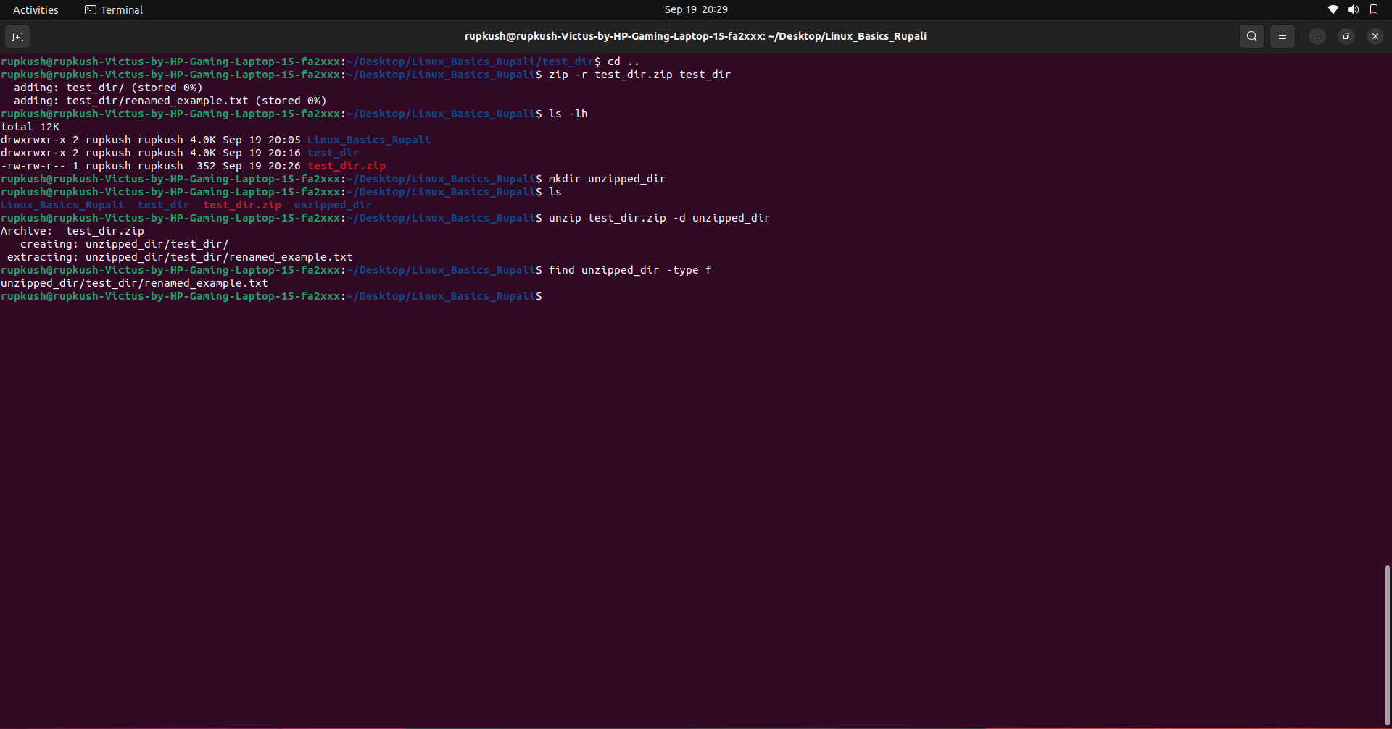

Task 5 — Downloading Files

10. Download a file using wget

Command used
wget https://raw.githubusercontent.com/github/gitignore/main/Global/Linux.gitignore

Explanation
wget is a command-line utility used to download files from the internet.
The provided example URL in the assignment returned a 404 Not Found response because the requested file was not available at that URL. Therefore, a valid publicly available text file was used to demonstrate the wget command successfully.
The downloaded file was saved as:
Linux.gitignore

Verification
ls -lh Linux.gitignore

Screenshot
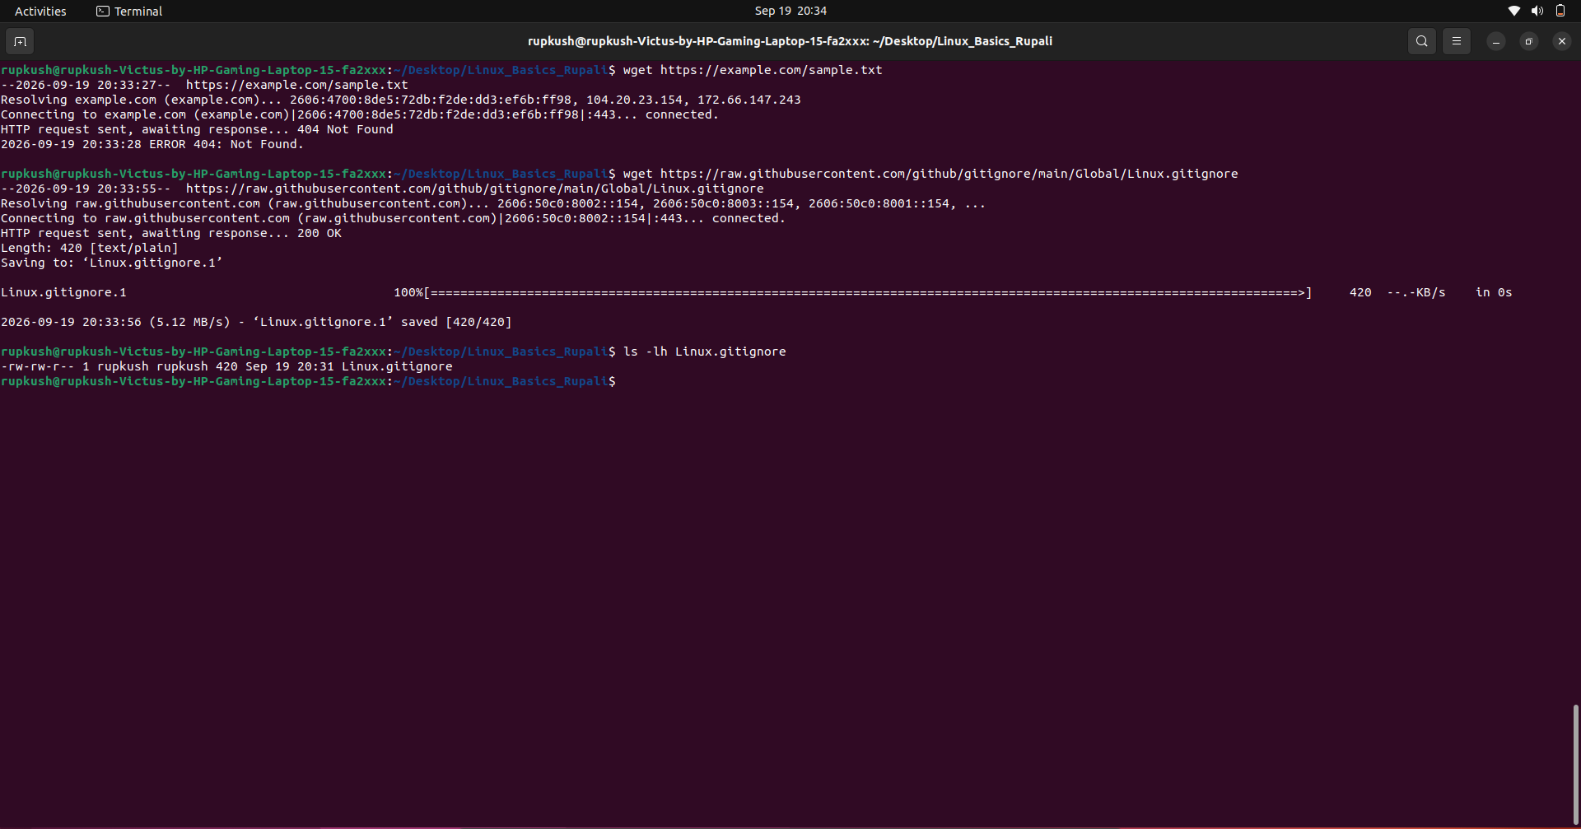

Task 6 — Changing File Permissions

11. Create secure.txt and make it read-only for everyone

Create the file
touch secure.txt

Change permissions
chmod 444 secure.txt

Verify permissions
ls -l secure.txt

Expected permission format
-r--r--r--

Explanation
The chmod command is used to change file permissions.
- Owner: Read permission
- Group: Read permission
- Others: Read permission
No write or execute permissions are provided.
The permission representation:
-r--r--r--
means that the file is read-only for everyone.

Screenshot
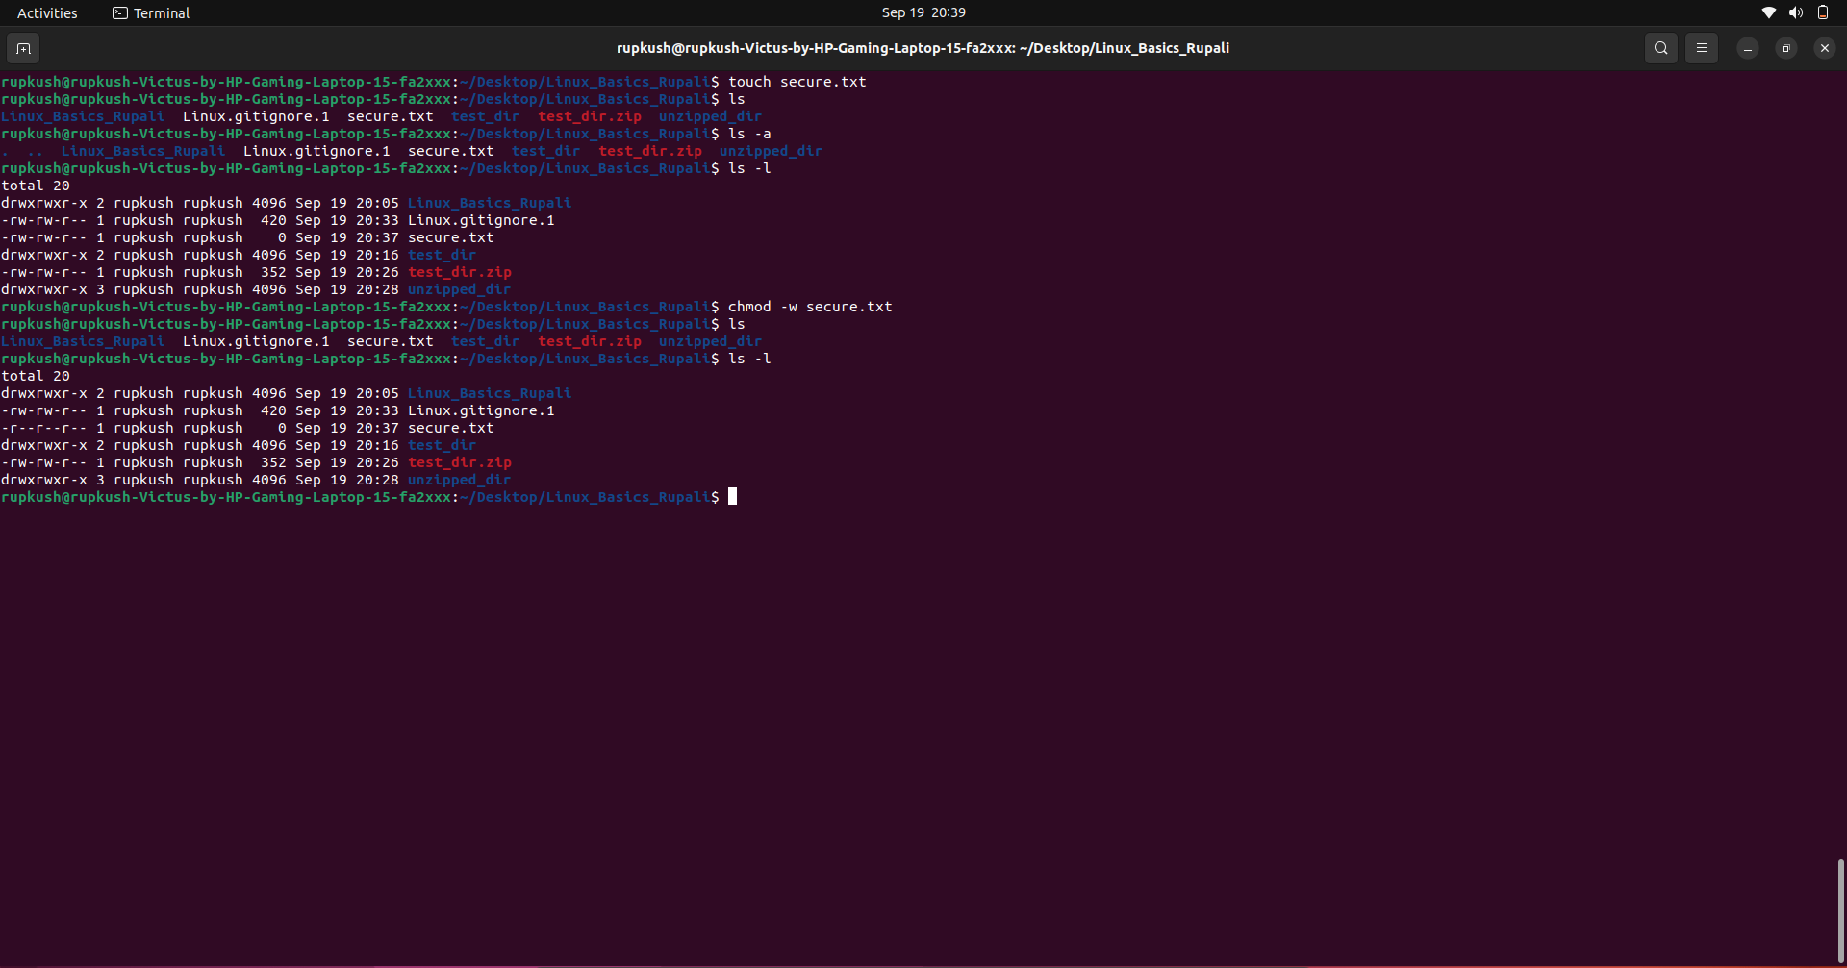

Task 7 — Working with Environment Variables

12. Create an environment variable named MY_VAR

Command
export MY_VAR="Hello, Linux!"

Explanation
The export command is used to create an environment variable that is available to the current shell and to processes started from that shell.
In this task, the variable MY_VAR was assigned the value:
Hello, Linux!

Verify using echo
echo $MY_VAR

Output
Hello, Linux!

Additional verification
printenv MY_VAR

Output
Hello, Linux!
This confirms that the environment variable was successfully created.

Screenshot
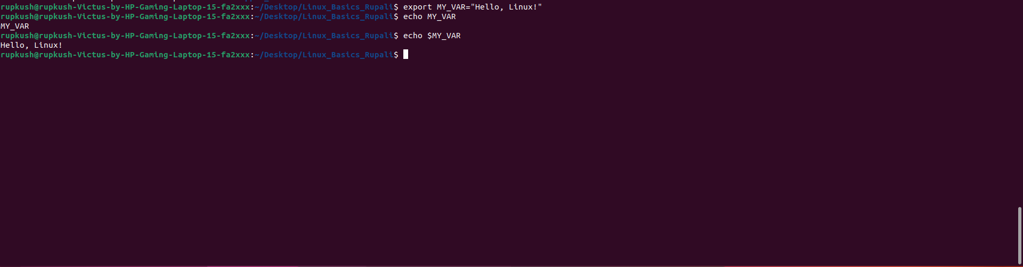

Project Directory Structure
After completing all the tasks, the project directory contains the following files and directories:
Linux_Basics_Rupali/
│
├── Linux.gitignore
├── secure.txt
├── test_dir/
│ └── renamed_example.txt
│
├── test_dir.zip
│
└── unzipped_dir/
└── test_dir/
└── renamed_example.txt

Commands Practised
The following Linux commands were practised during this assignment:
Command | Purpose
mkdir | Create directories
touch | Create empty files
mv | Rename or move files
ls | List files and directories
cat | Display file contents
head | Display the beginning of a file
tail | Display the end of a file
grep | Search for patterns
zip | Compress files/directories
unzip | Extract ZIP archives
wget | Download files from the internet
chmod | Change file permissions
export | Set environment variables
echo | Display variable values
printenv | Display environment variables
find | Search for files/directories

Conclusion
This assignment provided practical experience with essential Linux command-line operations. I learned how to create and rename files and directories, view and search file contents, compress and extract directories, download files using wget, modify file permissions using chmod, and create environment variables using export.
These commands are fundamental Linux skills and are useful for system administration, software development, cloud computing, and DevOps workflows.

GitHub Repository
Repository Link:
https://github.com/KUSHRUP/Linux-Basics-DevOps.git
The GitHub repository contains the project files and documentation associated with this assignment.

